Child Play Time Monitor – Project Documentation
1. Project Overview
Child Play Time Monitor is a Python-based desktop application that helps parents control and limit the amount of time children spend playing computer games.
The program:
- Scans running processes every 5 seconds.
- Detects when a game (from a user-defined list) starts or stops.
- Logs each gaming session to a CSV file.
- Displays daily playtime statistics as a bar chart.
- Shuts down the PC automatically when a daily time limit is exceeded.
- Provides a REST API (built with FastAPI) to manage game lists, adjust limits, and retrieve statistics remotely.
- Can be packaged and run inside a Docker container.

2. Features
Feature | Description
Process monitoring | Uses psutil to list all running processes every 5 seconds.
Game detection | Compares process names against a configurable set of game executables.
Session logging | Writes start time, end time, game name, and duration to playtime.csv.
Daily chart | Displays a bar chart (via matplotlib) of today’s playtime per game.
Time limit | Parent can set a daily limit (in minutes); when exceeded, a warning appears and the PC shuts down after 60 seconds.
REST API | Full CRUD operations on game list, limit management, statistics, and student list (for academic requirements).
Docker support | Includes a Dockerfile to containerise the REST API server.

3. Technology Stack
- Language: Python 3.10+
- Process scanning: psutil
- Data storage: CSV (built-in csv module)
- Charting: matplotlib
- Web framework: FastAPI
- ASGI server: uvicorn
- Containerisation: Docker
- Testing: unittest with mock

1. 用例图（Use Case Diagram）
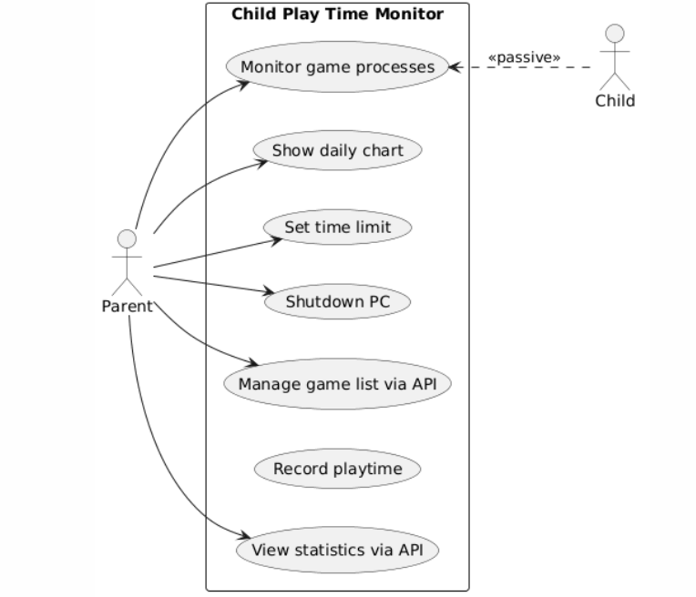

2. 系统架构图（Component Diagram）
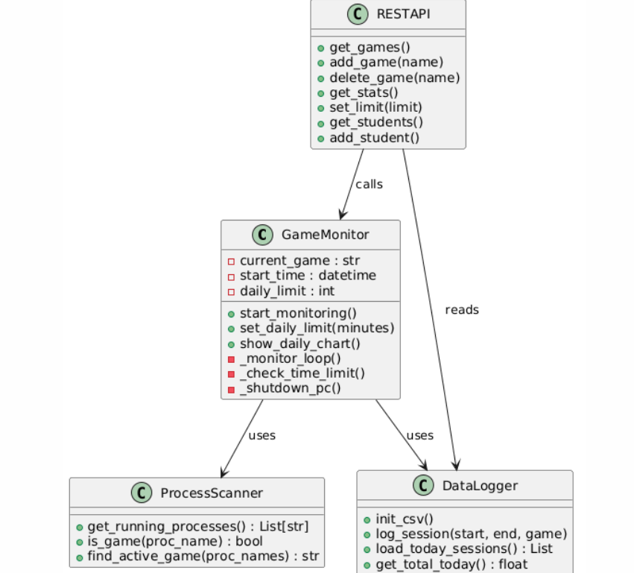

序列图1：游戏开始检测
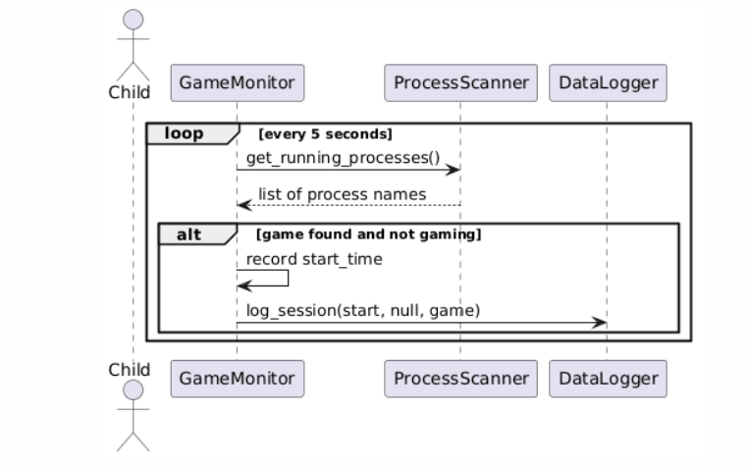
序列图2：游戏结束检测
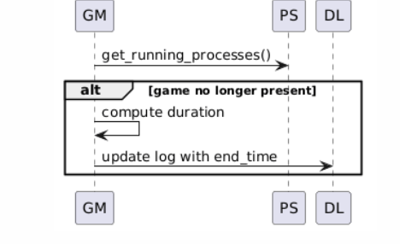
序列图3：时间超限自动关机
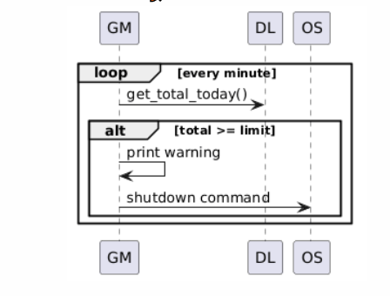
活动图:
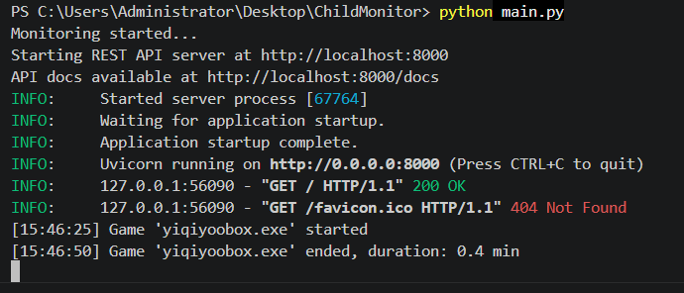
Backlog 表格

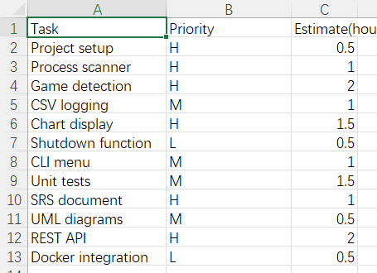

4. Conclusion
The Child Play Time Monitor successfully fulfills all practical lesson requirements:
Lesson 1: SRS, backlog, UI prototype.
Lesson 2: UML class diagram, sequence diagrams, unit tests with mocks.
Lesson 3: Fully working Python implementation with process monitoring, logging, charting, and auto‑shutdown.
Lesson 4: REST API (FastAPI) with full CRUD operations, Docker containerisation.

All source code, documentation, and diagrams are provided in the submission archive.

